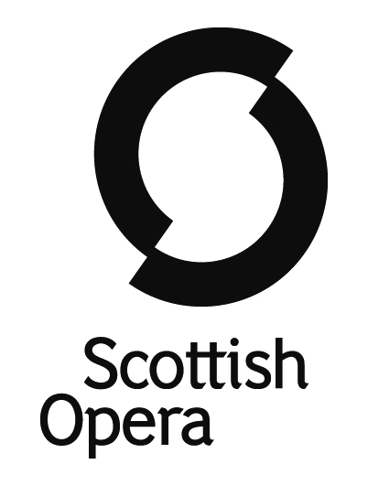

The Orchestra of Scottish Opera

Music Director – Stuart Stratford
Leader – Anthony Moffat

Section Principal 2nd Violin

Salary – £711.10 per week plus benefits

Scottish Opera takes world-class opera to all corners of Scotland, ensuring that as many people as possible can enjoy this wonderful art form. The company is Glasgow based and the Orchestra performs main stage and medium-scale operas, participates in education and outreach work and performs concerts and recordings throughout Scotland and beyond.

We invite applications for the position of Section Principal 2nd Violin. Players have a contractual guarantee of a minimum of 29 weeks of work per year, and in November each year receive
5 months’ notice of their contracted weeks of work for the year that commences from April.

Auditions for this position will take place in Glasgow on the following dates:

1st Round
Audio Visual Digital Submission

2nd and 3rd Rounds
Tuesday 2nd August (2nd round in the AM and 3rd round in the PM)
Wednesday 3rd August (2nd round in the AM and 3rd round in the PM)

All candidates must be able to demonstrate a pre-existing right to work in the UK and documentary proof of this will be requested prior to auditions.

Applicants should apply via Musical Chairs www.musicalchairs.info. To be considered for an audition, your application must include all of the documents specified on the Musical Chairs Website. If you have any queries regarding your application, please contact our Orchestra Manager, Heather North at heather.north@scottishopera.org.uk
The closing date for applications and Audio Visual recordings is Tuesday 7th June 2022 at 5pm.
We have a strong commitment to promoting equality, and we particularly encourage applications from people who are under-represented in the performing arts. To eliminate any unconscious bias, we have introduced an anonymised application process and screened auditions for 1st and 2nd Rounds.

Scottish Opera strives to be an equal opportunities employer and is subsidised by the Scottish Government. Registered Number SCO37531. Scottish Charity Number SCO19787

