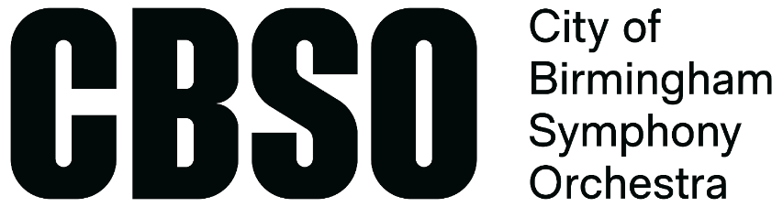

WORK WITH THE CBSO
Career Accelerator

TITLE: Career Accelerator Fellow
TIME COMMITMENT: Up to 60 days across the contracted period
PAY: Appropriate freelance rates for work undertaken. Earnings up to £10,000.
LOCATION: Performances, workshops, and rehearsals to take place in Birmingham and the West Midlands
TIME FRAME: September 2023 – August 2024
POSITIONS AVAILABLE: 2 x Violin, Viola, Cello, Double Bass
DEADLINE TO APPLY: 15th June 2023

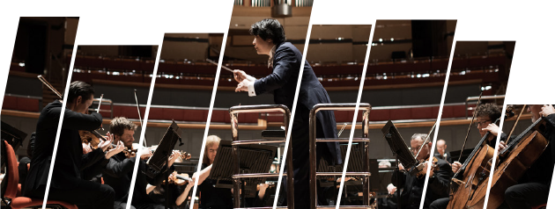
ABOUT THE CBSO
The City of Birmingham Symphony Orchestra (CBSO) is the flagship of musical life in Birmingham and the West Midlands, and one of the world’s great orchestras.
Resident at Symphony Hall in Birmingham, the orchestra performs over 150 concerts each year in Birmingham, the UK and around the world, playing music that ranges from classics to contemporary, film music to symphonic disco, and everything in between. With a far-reaching community programme and a family of choruses and ensembles, it is involved in every aspect of music-making in the Midlands. But at its centre is a team of 90 superb professional musicians, and more than 100-years of making great music in the heart of Birmingham.
WHAT IS CAREER ACCELERATOR?
A paid career development opportunity for five early-career string players, which offers up to 60 days of freelance work across the CBSO’s artistic season. This includes full orchestral performances, chamber work, and participating in our wide-ranging Learning & Engagement programme. The Career Accelerator also features a tailored training package to help develop the skills required of a 21st century orchestral musician.
The Career Accelerator programme is aimed at musicians from currently under-represented backgrounds in the orchestral world. We ask for musicians to self-identify their under-represented protected characteristics, communities, or identities in their application. This may include musicians from the Global Majority; Deaf, Disabled, or neurodivergent musicians; those from LGBTQ+ community; those from marginalised genders; and those from lower socio-economic backgrounds.
The CBSO’s Career Accelerator programme is supported by the Esmée Fairbairn Foundation and the Foyle Foundation.
We work closely with our partners Black Lives in Music and Sheffield Performer and Audience Research Centre to ensure that the programme meets the needs of the musicians that apply.

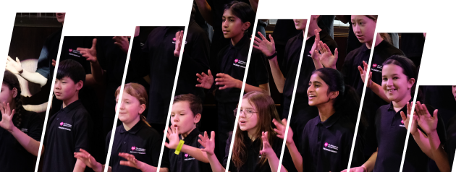
What will the Career Accelerator programme include?
- Up to 60 days of paid freelance work with the CBSO across the calendar year: including full orchestral performances, Learning & Engagement work, and other activities
- Recurring consultation/mentoring sessions from CBSO musicians across the year
- A comprehensive CPD programme to enable musicians to plan, deliver, and reflect upon smaller scale performances and Learning & Engagement activities
- Opportunities to observe rehearsals for projects happening across the year
- Access to other CPD and training opportunities on offer to the CBSO’s musicians during the year
- If musicians are based outside of the Midlands, travel allowances for each day required in Birmingham
- A dedicated CBSO musician mentor for day-to-day and performance-related enquiries
- A dedicated CBSO Senior Management contact for pastoral, safeguarding, and wellbeing enquiries
- A dedicated CBSO Board Trustee contact to ensure direct contact with the organisation’s governing body
What is the time commitment?
- Up to 60 days between September 2023 and August 2024. Dates to be offered after successful auditions, in line with the CBSO schedule.
- Compulsory attendance at a training event on Fri 1 September 2023
- Compulsory attendance at online and in-person evaluation meetings throughout the programme (dates TBC)
Who is it for?
We are recruiting for five string positions to join the CBSO Career Accelerator programme in 2023. We welcome applications from violin, viola, cello, and double bass players.
The applicants will be early-career string musicians looking to kick-start their career as orchestral musicians. Musicians must be performing at the standard required to play in a professional symphony orchestra and may include those that are:
- Recently out of higher education but yet to establish an orchestral career
- In part-time or full-time higher education with a commitment to pursue a career in orchestral performance
- Considering a career change or move into orchestral performance
- Musicians who have not yet established an orchestral career but are keen to do so
Applicants must commit to the CBSO’s mission, ‘every life enriched by music’, as well as our core values:
- Love what we do
- Collaborate and inspire
- Be open and adventurous
- Respect others
Applicants must be aged 18 or over by 1 September 2023. There is no upper age limit.
Applicants must be able to demonstrate the right to work in the UK and proof of this will be required prior to confirmation of places on the Career Accelerator.

POSITIVE ACTION
The classical music workforce is not representative of the UK population: it is less ethnically diverse than those coming through the conservatoire system, with people from ethnically diverse backgrounds under-represented in all areas of classical music organisations including musician membership; it is under-representative of those from lower socio-economic statuses; Disabled artists are significantly under-represented; and women and those from marginalised genders still fair less well in some competitive processes for elite training opportunities (Arts Council England, 2021).
The CBSO Career Accelerator prioritises access for string players currently under-represented in our sector including, but not limited to, the following:
- Musicians from the Global Majority
- Deaf, Disabled, and neurodivergent musicians
- LGBTQ+ musicians
- Those from lower socio-economic backgrounds
- Women and marginalised genders in particular instruments

Applicants will also be asked to self-identify any under-represented protected characteristics, identities, or communities with which they identify as part of this process.
Applicants will also be asked to complete a private Equality & Diversity Monitoring form that will not be connected back to their application.
Where applicants meet the minimum required criteria at Round 1, which includes performance material and written responses, and have identified under-represented protected characteristics, they will be guaranteed a live audition at Round 2.
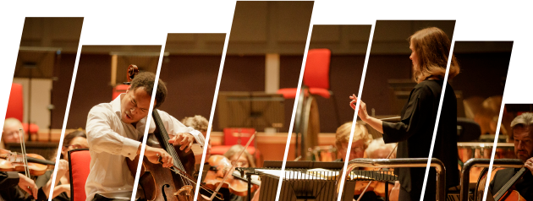
RECRUITMENT PROCESS
Round 1- Application form and digital audio audition
- Complete an online application form linked below
- Record your audition (audio only) as per the guidelines listed in Appendix 1, and upload this file as part of your online application form by Friday 15 June 2023.
Round 2- live auditions and interviews
Candidates that pass the digital first round of auditions will be invited to attend a live audition in Birmingham. Live second round auditions will take place on:
- Wednesday 12 July 2023
- Thursday 13 July 2023
All live second round auditions will take place at the CBSO Centre, Berkley Street, Birmingham B1 2LF. These will involve a short session of chamber music with CBSO musicians and an informal chat to get to know you and your interest in the scheme. Candidates will be able to claim £50 travel reimbursement if travelling from outside of the West Midlands.
Full audition requirements are available in Appendix 1 of this form.
Timeline
Tuesday 16 May | Applications open
Thursday 15 June | Applications close (including Digital First Round auditions)
Wednesday 12 and Thursday 13 July | Live Second Round auditions in Birmingham
Late-July 2023 | Confirmation of places on the Career Accelerator
August – date TBC | Introductory conversation with CBSO management team
Friday 1 September 2023 | Training event in West Bromwich
September 2023 – September 2024 | Career Accelerator programme delivery
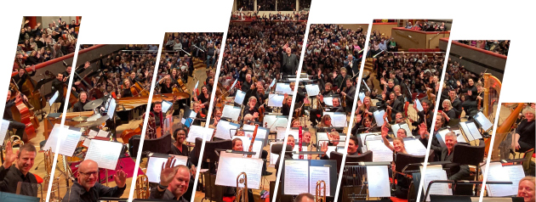
APPENDIX 1

Application Form
https://forms.office.com/e/3Yj63kMKdp
Violin Auditions
Violin audition booklet available here: https://www.dropbox.com/s/j262wzybyewkf6c/CA%20-%20Violin%20Audition%20Booklet%2023-24.pdf?dl=0
Please note that successful applicants will experience playing with both the first and second violin sections at the CBSO.
Viola Auditions
Viola audition booklet available here: https://www.dropbox.com/s/fbkd5tzexz8bvf3/CA%20-%20Viola%20Audition%20Booklet.pdf?dl=0
Cello Auditions
Cello audition booklet available here: https://www.dropbox.com/s/0ij88sqnj5arpn5/CA%20-%20Cello%20Audition%20Booklet%2023-24.pdf?dl=0
Double Bass Auditions
Double Bass audition booklet available here: https://www.dropbox.com/s/ohx3vz7pvivniuy/CA%20-%20Double%20Bass%20Audition%20Booklet%2023-24.pdf?dl=0

