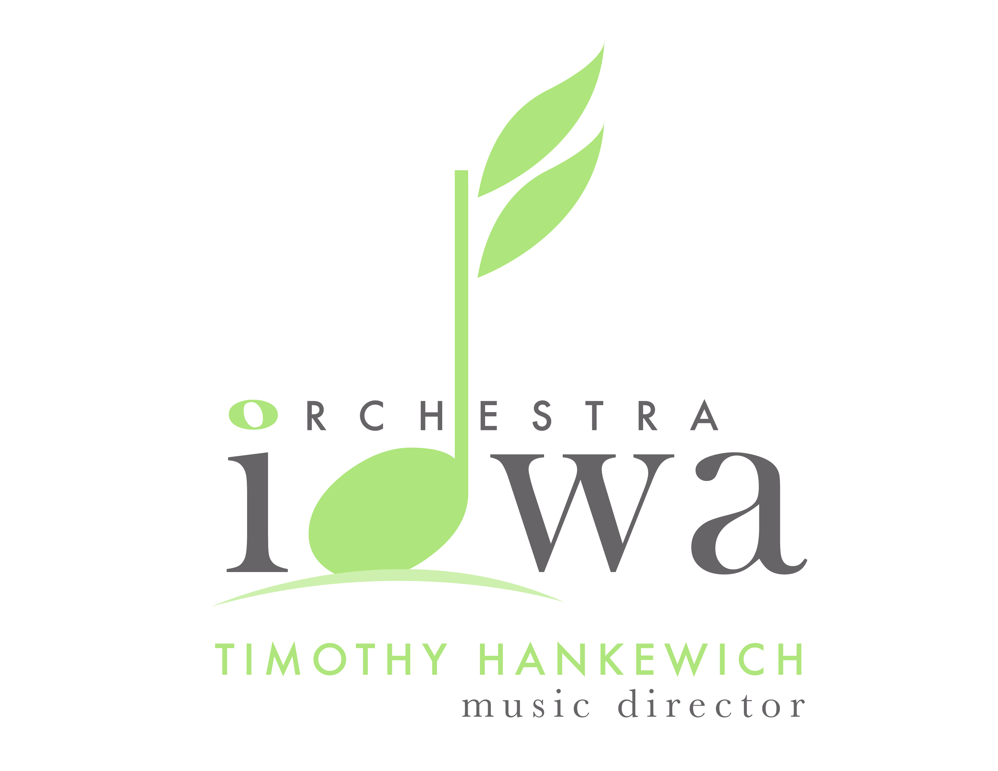

Announces auditions for the position of

Section Viola

Thursday, October 6, 2022

Orchestra Iowa Building
119 3rd Ave SE
Cedar Rapids, IA 52401

Founded in April 1923, Orchestra Iowa is one of the oldest symphony orchestras in continuous operation west of the Mississippi River. Its 68 professional musicians perform more than 190 public performances throughout Eastern Iowa each year, many of which can be heard on Iowa Public Radio and seen on Iowa Public Television. The Orchestra teaches more than 500 students each year through the Orchestra Iowa School.

Orchestra Iowa performs symphonic, operatic, ballet, musical theatre and youth concerts throughout Iowa. Concerts are primarily presented in Cedar Rapids and Iowa City, with additional performances taken throughout the state. Chamber ensembles from the Orchestra perform educational concerts through its Pied Piper Series (pre-school concerts presented at libraries) and Music in the Schools (performances in elementary school classrooms). These ensembles are also featured in recital on the Shuttleworth Chamber Series, presented at the Orchestra’s Opus Concert Café and broadcast statewide on Iowa Public Radio.

Section Viola is a Group B2 position with a fifty (50) service guarantee. Starting per service rate is $100.00 and travel/housing reimbursements may also be available. Orchestra Iowa is a member of the Regional Orchestra Players Association (ROPA) and operates under a Collective Bargaining Agreement with the American Federation of Musicians.

Auditions will take place on Thursday, October 6, 2022 at the Orchestra Iowa building in
Cedar Rapids, IA. To secure an audition time, please complete the registration form (attached) and return along with a resume and $25 audition deposit no later than September 28, 2022. Candidates will be notified of their audition time via email by October 4. Please note that the preliminary rounds of the audition will be screened. The audition committee has the option to remove the screen in subsequent rounds. The winning candidate must already be eligible to work in the United States.

More information may be found at www.orchestraiowa.org

Section Viola Audition Registration Form

Name:

Address:

City/State/Zip:

Mobile Phone:

Email Address:

Please return this page, along with a resume that includes education, performance history and other relevant experience, along with a refundable $25 audition deposit no later than September 28 to:

Ed Karr, Chief Operating Officer

Orchestra Iowa

119 Third Avenue SE

Cedar Rapids, IA 52401

Candidates will receive notification of audition time via email by October 4. Should you not receive notification by then, please contact the Orchestra at 319.366.8206.

