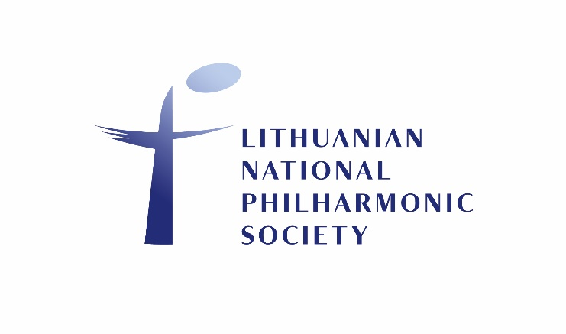
VILNIUS STRING QUARTET
CELLO

Violoncello: One position
1st Round: July 1, 2022 (Video Recording Audition)
2nd Round: August, 2022 (Live Audition)

Closing date for video applications is 1 July 2022.
Preliminary Second Round: August, 2022 (Live Audition)
Permanent employment with a trial period as agreed.

VIDEO RECORDING AUDITION
Your application must be delivered by July 1, 2022 to personalo.skyrius@filharmonija.lt and must contain:
- Name, surname, phone number and email address
- CV
- quality video recording of one cello solo piece and one camber performance. The video must be no older than 5 years.
LIVE AUDITION
Secon Round will take place by personal invitation on the Augest-September 2022 at the Lithuanian National Philharmonic Society, Aušros vartų st. 5, LT-01304 Vilnius.

For queries regarding the audition, please contact: personalo.skyrius@filharmonija.lt

